Project Report
On



DIGITAL
SIGNATURE

Digital Signature

Prepared by

(MCA – VIth Sem)

Submitted to

Project Guide

DECLARATION

we,…… Names…… student of MCA program, VI Semester of 2006 – 2009 batch at ………. University do hereby declare that this report entitled “Digital Signature“ has been carried out by me during this Semester and the same work has not been copied from any source directly without acknowledging for the part/ section that has been adopted from published / non-published works.

__________________

INDEX & TABLES

- About Project
- Objective
- Project Profile
- Problem Definition
- Proposed System and Targeted User
7. Specific Requirement Specifications
8. System Development
- Data Design
Entity-Relationship Diagram
- System Design
UML
Data Flow Diagram
- Bibliography

ABOUT THE ORGANISATION

About Project

Abstract

The security of information available to an organization was primarily provided through physical and administrative means. For example, rugged file cabinets with a combination lock were used for storing sensitive documents and personnel screening procedures were employed during the hiring process. With the introduction of the computer, the need for automated tools for protecting files and other information stored on the computer became evident.
This is especially the case for a shared system and the need is even more acute for a network. Computer networks were primarily used by university researches for sending e-mail, and by corporate employees for sharing printers. Under these conditions, security was not given much attention. Today, since the world is going global, and trillions of data are transferred daily across networks, security is looming on the horizon as a potentially massive problem. The generic name for the collection of tools designed to protect data and to thwart hackers is Computer Security.
In the project titled “Digital Signatures” security is ensured in the Messaging System of an organization. In this application, if an employee wishes to send confidential information to another employee connected through the intranet of their organization, he

first signs the message and then sends it to the recipient. He signs the message using Digital Signatures. The person who receives the message validates the sender and if the message is from an authorized employee, he reads the message. The above operation is performed using Digital Signature Algorithm (DSA). This application makes sure that the security services Authentication, Secrecy, Integrity, and Non-repudiation are provided to the user. Therefore, intruders cannot gain access to classified information.

2. INTRODUCTION
Scope
The project is confined to the intranet in an organization. This application makes sure that security services such as secrecy, authentication, integrity and non-repudiation are provided to the communicating parties.
Objective
This project has been developed keeping in view the security features that need to be implemented in the networks following the fulfillment of these objectives:

- To develop an application that deals with the security threats that arise in the network.
- To enable the end-users as well as the organizations come out with a safe messaging communication without any threats from intruders or unauthorized people.
- To deal with the four inter-related areas of network security namely Secrecy, Authentication, Non-repudiation and Integrity.
Project Overview
This application makes use of Digital Signature Algorithm (DSA) along with a hash function. The hash code is provided as input to a signature function along with a random number generated for this particular signature. The signature function also depends on the sender’s private key and a set of parameters known

to a group of At the receiving end, verification is performed. The receiver generates a quantity that is a function of the public-key components, the sender’s public key, and the hash code of the incoming message. If this quantity matches with one of the components of the signature, then the signature is validated.
This application makes sure that the security services Authentication, Secrecy, Integrity, and Non-repudiation are provided to the user.
- This application allows to keep the information out of the hands of unauthorized persons. This is called Secrecy.
- It also deals with determining whom a person is communicating with before revealing sensitive information or entering a business deal. This is called Authentication.
- Non-repudiation deals with proving that a particular message was sent by a particular person in case he denies it later.
- Integrity makes sure whether a particular message has been modified or something has been added to it.

Project Profile

► | Product Name | : | DigitalSignature (A secure Messaging system)
► | Project Objective | : | This application makes sure that the security services Authentication, Secrecy, Integrity, and Non-repudiation are provided to the user. Therefore, intruders cannot gain access to classified information.
► | SDLC Model | : | Water Fall Model
► | Development Technologies | : | Java/J2EE
► | Application Server | : | Oracle Weblogic Application Server Enterprise Edition
► | Back-End Database | : | Oracle Database 10g Enterprise Edition
► | Location | : | ………. ,Noida

Problem Definition

Message authentication protects two parties who exchange messages from any third party. However, it does not protect the two parties against each other. Several forms of disputes between the two parties are possible.

For example, suppose that A sends an authenticated message to B. Consider the following disputes that could arise:
- B may forge a different message and claim that it came from A. B would simply have to create a message and append an authentication code using the key that A and B share.
- A may deny sending the message. Because it is possible for B to forge a message, there is no way to prove that A did in fact send the message.

The most attractive solution to this problem is the Digital Signature. The Digital Signature is analogous to the handwritten signature. It must have the following properties:

  - It must be able to verify the author and the date and time of the signature.

  - It must be able to authenticate the contents at the time of the signature.
  - The signature must be verified by third parties, to resolve disputes.

Thus, the digital signature function includes the authentication function.
Based on the above properties, the following requirements can be formulated for the digital signatures:
- The signature must be a bit pattern that depends on the message being signed.
- The signature must use some information unique to the
sender, to prevent both forgery and denial.
- It must be relatively easy to produce the digital signature.
- It must be relatively easy to recognize and verify the digital signature.
- It must be computationally infeasible to forge a digital signature, either by constructing a new message for an existing digital signature or by constructing a fraudulent digital signature for a given message.
- It must be practical to retain a copy of the digital signature in storage.

Proposed System & Targeted User

Existing system
These days almost all organizations around the globe use a messaging system to transfer data among their employees through their exclusive intranet. But the security provided is not of high standards. More and more unauthorized people are gaining access to confidential data.

Disadvantages:
- The validity of sender is not known.
- The sender may deny sending a message that he/she has actually sent and similarly the receiver may deny the receipt that he/she has actually received.
- Unauthorized people can gain access to classified data.
- Intruders can modify the messages or the receiver himself may modify the message and claim that the sender has sent it.

Proposed system
The system will provide the following security services:

Confidentiality:
Confidentiality is the protection of transmitted data from passive attacks. With respect to the release of message contents, several levels of protection can be identified. The broadest service protects all user data transmitted between two users over a period of time. For example, if a virtual circuit is set up between two systems, this broad

protection would prevent the release of any user data transmitted over the virtual circuit. Narrower forms of this service can also be defined, including the protection of a single message or even specific fields within a message. These refinements are less useful than the broad approach and may even be more complex and expensive to implement. The other aspect of confidentiality is the protection of traffic flow from analysis. This requires that an attacker not be able to observe the source and destination, frequency, length, or other characteristics of the traffic on a communications facility.

Authentication:
The authentication service is concerned with assuring that a communication is authentic. In the case of a single message, such as a warning or alarm signal, the function of the authentication service is to assure the recipient that the message is from the source that it claims to be from. In the case of an ongoing interaction, such as the connection of a terminal to a host, two aspects are involved. First, at the time of connection initiation, the service assures that the two entities are authentic (i.e. that each is the entity that it claims to be). Second, the service must assure that the connection is not interfered with in such a way that a third party can masquerade as one of the two legitimate parties for the purposes of unauthorized transmission or reception.
Integrity:
Integrity basically means ensuring that the data messages are not modified. An integrity service that deals with a stream of messages assures that messages are received as sent, with no

duplication, insertion, modification, reordering or replays. The destruction of data is also covered under this service. Thus the integrity service addresses both message modification and denial of service.
Non-repudiation:
Non-repudiation prevents either sender or receiver from denying a transmitted message. Thus, when a message is sent, the receiver can prove that the message was in fact sent by the alleged sender. Similarly, when a message is received, the sender can prove that the message was in fact received by the alleged receiver.

Database Description

Entity: Login_digisafe
Role: To maintain the username and the related password of different users.
Attributes:

NAME | NULL? | TYPE
Username | Not null | Varchar2
Password | Not null | Varchar2
Question |  | Varchar2
Answer |  | Varchar2
Check1 |  | Number

Entity: Inbox_digisafe
Role: To maintain the received mails of different users.
Attributes:

NAME | NULL? | TYPE
Username_sender | Not null | Varchar2
Username_receiver | Not null | Varchar2
Subject |  | Varchar2
Message |  | Varchar2
Message_digest | Not null | Long raw
Message_key | Not null | Varchar2
Message_date | Not null | Date
Check1 | Not null | Number

Entity: sent_digisafe
Role: To maintain the sent mails of different users.
Attributes:

NAME | NULL? | TYPE
Username_sender | Not null | Varchar2
Username_receiver | Not null | Varchar2
Subject |  | Varchar2
Message |  | Varchar2
Message_date | Not null | Date

Entity: certificate_digisafe
Role: To maintain the certificate of different users.
Attributes:

NAME | NULL? | TYPE
Username | Not null | Varchar2
Cfile |  | Varchar2

Entity: attachment_digisafe
Role: To maintain the files attached with message of different users.
Attribute:

NAME | NULL? | TYPE
Message_date |  | Varchar2
Attach1 |  | Varchar2
Message_digest1 |  | Varchar2
Attach2 |  | Varchar2
Message_digest2 |  | Varchar2
Attach3 |  | Varchar2
Message_digest3 |  | Varchar2
Attach4 |  | Varchar2
Message_digest4 |  | Varchar2
Attach5 |  | Varchar2
Message_digest5 |  | Varchar2

Data Design

E-R Diagram

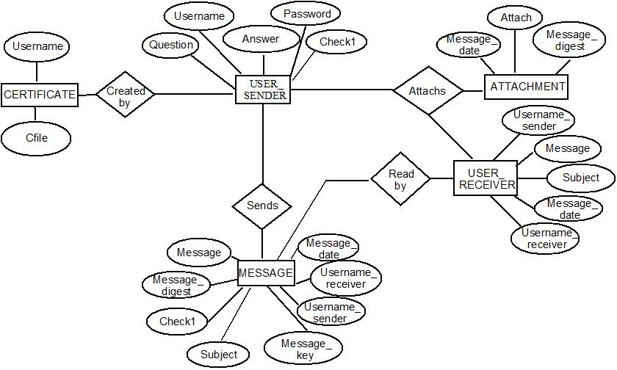

System Design

UML Diagram

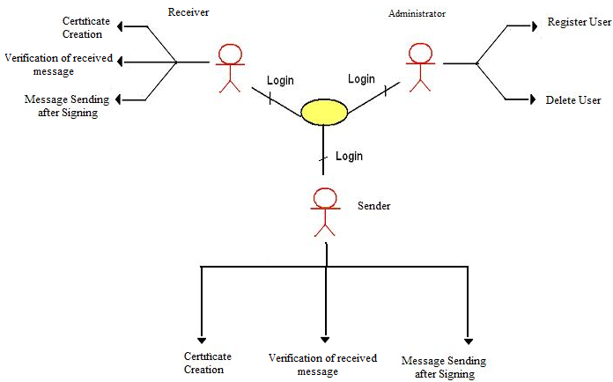

Data flow diagrams

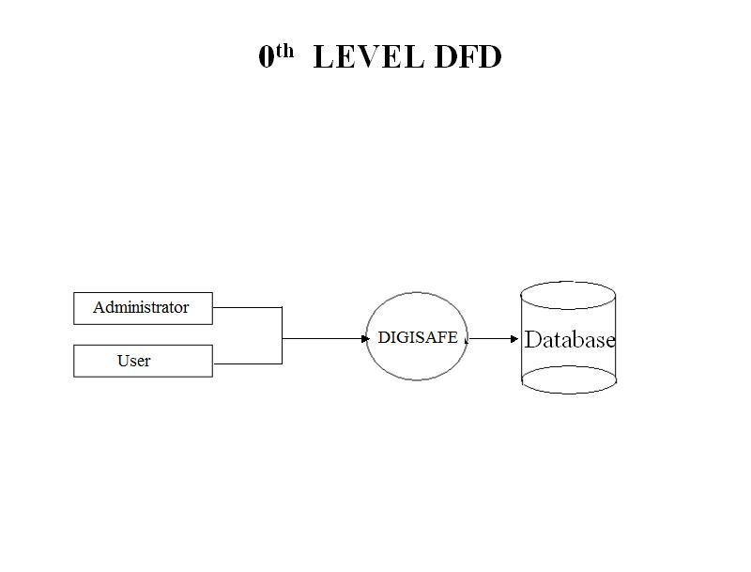

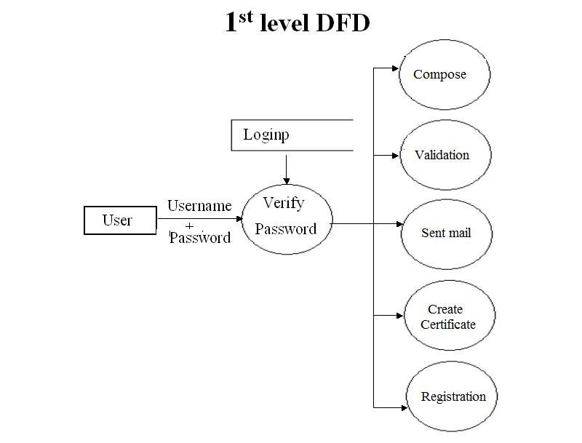

2ND Level DFD’S

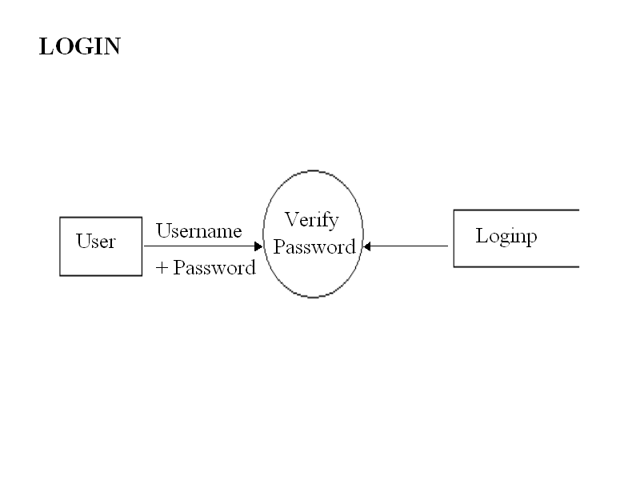

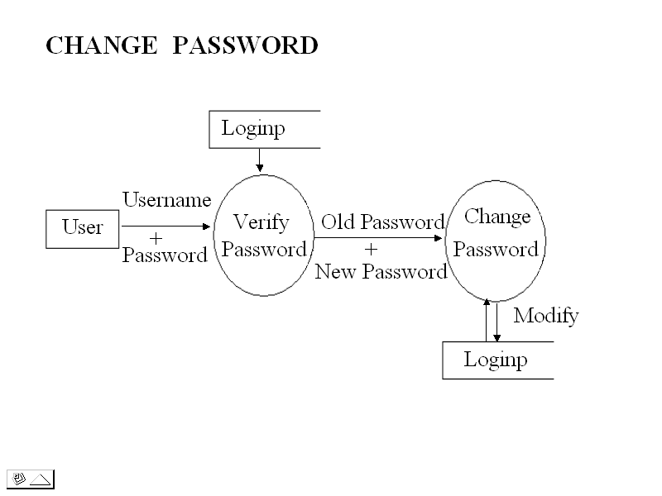

Compose Mail

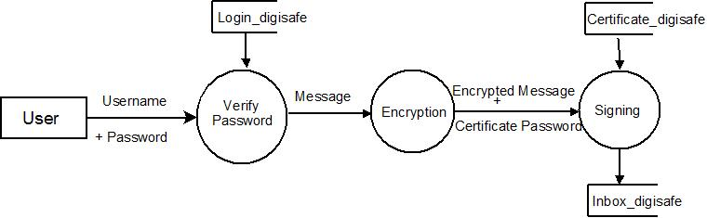

Validate Mail

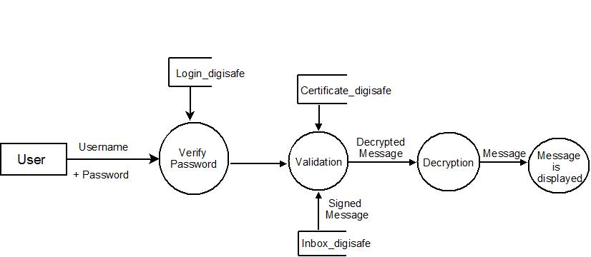

Create Certificate

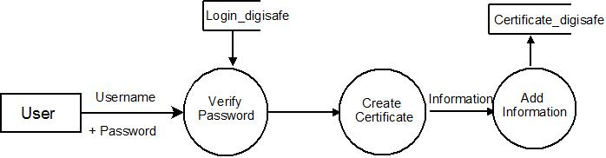

Sent Mail

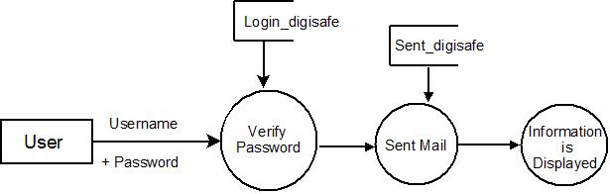

Bibliography

Bibliography

Web Resources

- www.java.sun.com
Official Java Website
- www.java.sun.com/developer/onlineTraining/J2EE/Intro2/j2ee.html
Training for J2EE
- www.java.sun.com/j2se/1.4.2/docs/api/index.html
J2SE Online Documentation from Sun
    - www.w3schools.com
JavaScript Tutorials

BOOKS

- API DOCS –JAVA, J2EE, Java Mail, Java Servlets, JSPs
By: Sun Microsystems

- Java2 - The Complete Reference(7TH Edition)
By: Herbert Schildt

- JSP - The Complete Reference
By: Philhanna

- Oracle 10g
By: Ivan Baross

- Software Engineering
By: Roger Pressman

- Head First Servlets & JSP
By: Bryan Bashan, Kathy Sierra & Bert Bates

